



***Contents:***

Welcome from the Consumer Co-ordinator…pg 1

The Steering Group Consumer Voice …pg 1

Consumer Stories…pg 2-6

Message from Colloquium Organisers…pg 2

Consumer Stipends for the Cochrane Colloquium …pg 2

Checklists for Consumer Referees…pg 3

Improving Access for Speakers of Non- English Languages…pg 3

Plain Language Expectations for Authors…pg 4

Report from the UK and Ireland Contributors Meeting…pg 5-6

**The Steering Group’s Consumer Voice**

# *Mingming Zhang and Liz Whamond*

The Cochrane Collaboration Steering Group (CCSG) had a teleconference on the 23rd of February, earlier this year. A major point of discussion was the CCSG Co-Chairs’ report on the loss of Alessandro Liberati and the departure of the Collaboration’s CEO, Nick Royle.

This required some members of the CCSG to become involved in the operational matters of running the Collaboration. A temporary replacement was sought, and Paul Farenden was appointed the Interim Executive Director on 1st March. For more information on this transition, please visit [**http://tinyurl.com/8ydknfz**](http://tinyurl.com/8ydknfz)**.**

Following these discussions, the CCSG received reports on the upcoming activities of the Collaboration. The next Cochrane Colloquium will begin on 30th September 2012 in beautiful Auckland, New Zealand. To register for the Colloquium, or to apply for a consumer stipend, visit<http://colloquium.cochrane.org/>.

Some important issues were discussed regarding the Editor in Chief’s report on the future publishing arrangements for the Collaboration and the application for formal partnership status with the EPPI-Centre (<http://eppi.ioe.ac.uk/cms/>).

More information about these discussions can be found in the CCSG minutes located at [**http://tinyurl.com/c8yqbgg**](http://tinyurl.com/c8yqbgg)**.**

The result is anincreased need for training resources that meet the needs of our members.

A new [training website](http://training.cochrane.org) has been created to bring all resources together for Cochrane participants. A section of the website is dedicated to consumers, so do check out the site.

Initially, key resources from CCNet have been posted, but I will be updating the site with additional resources in the future. The Collaboration has also hired a Training Co-ordinator, so stay tuned   
for new   
opportunities   
for consumer   
education at  
Cochrane.

Cochrane Summaries continues to provide consumers with information about health treatments, but some of the language has been found to be incomplete and potentially inaccessible for consumers for whom English is a second language.

Critiques by several CCNet members earlier this year have resulted in a consumer-led process to redefine the requirements for every plain language summary (see page 3 for additional information of this project).

This year has seen a tremendous number of consumers join CCNet. Over 1340 consumers are registered with The Collaboration, plus many newcomers who follow CCNet activities through [Facebook](https://www.facebook.com/groups/188375461224285/) and [Twitter](http://twitter.com/#!/cochranconsumer).

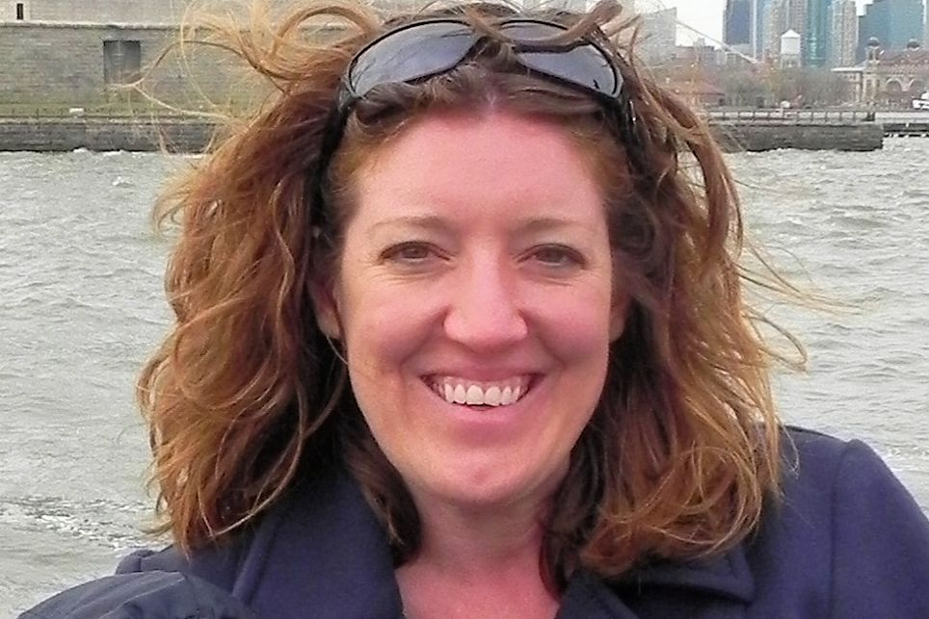

# **Welcome from the Consumer Co-ordinator**

# *Catherine McIlwain*

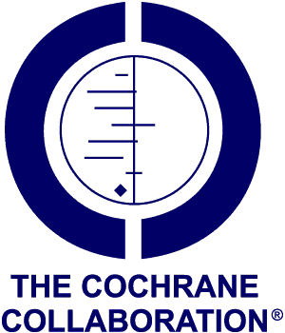

**April 2012**



***Pullman Hotel, Auckland***

## **Message from the Colloquium organizers**

**Kia ora and Haere Mai (Welcome)**  
  
Welcome to the 20th Cochrane Colloquium which will be held in Auckland from 30 September to 3 October 2012. Planning is now well underway and we are preparing an exciting scientific programme and a varied social schedule that gives you an opportunity to enjoy the sights and culture of our lovely city.

New Zealand is increasingly a nation of many different cultures but the flavour is predominantly Polynesian. Auckland (New Zealand’s largest city) is the largest Polynesian city in the world and we enjoy the vibrant culture that comes from the many Maori and Pacific inhabitants.   
Auckland is built on a narrow isthmus between two large bodies of water, the Pacific Ocean and the Tasman Sea. As a result the climate is temperate and we have many beautiful beaches to visit.

The venue is the Pullman Hotel and we have been fortunate in booking the whole venue. There are other options for accommodation nearby. The hotel is close to the University, the central business district and our beautiful harbour.

In the next few months we will be preparing the meeting programme and we welcome any suggestions on content and topics for inclusion.

**Consumer   
 Stories**

I came to The Collaboration in 1999 as a Canadian consumer…   
I had my reasons.  In 1993 I was diagnosed with breast cancer.  Six weeks were spent in a hostel 60 miles from my hometown receiving radiation treatments. I knew no one in the hostel and had lots of time on my hands as I didn’t go home between treatments.  I was interested in the latest breast cancer research and asked the hospital for permission to access the library to read breast cancer research papers.  I was told it was not open to the public.  Needless to say, I was very upset by this news.  I reasoned that tax payer dollars had been used to fund the library to acquire this information and yet I was denied access to the papers.  There became my quest for knowledge.

***Read more about Liz’s story at*** [consumers.cochrane.org/blog](http://consumers.cochrane.org/blog)

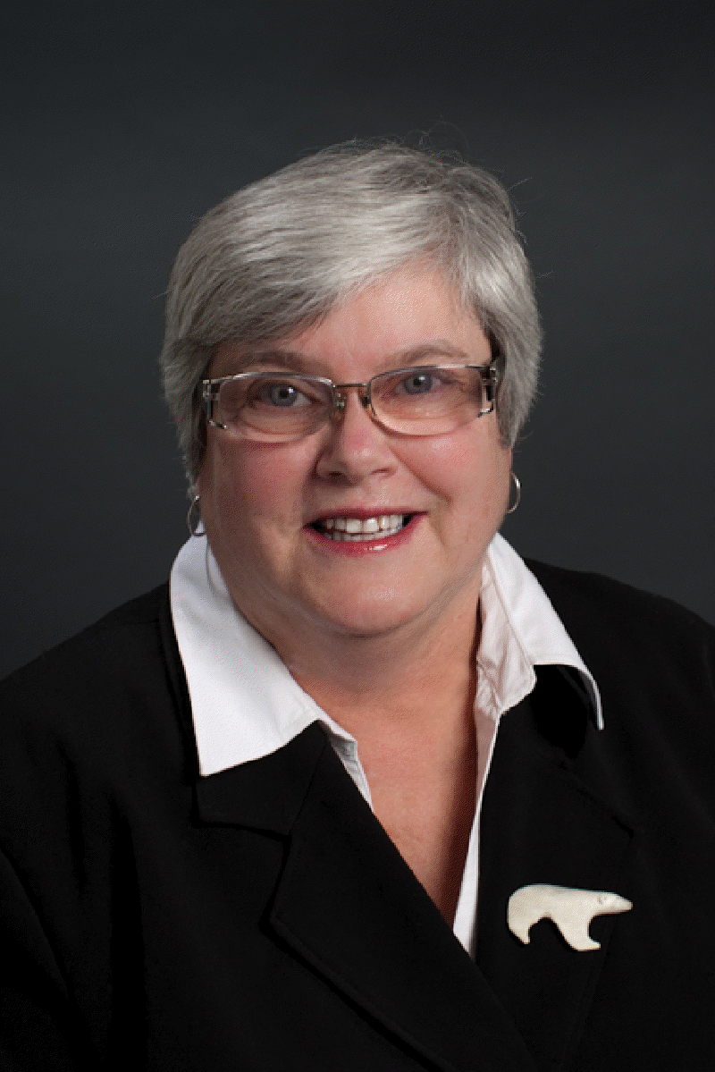

***Stipends application deadline: Thursday 31 May 2012***

***Stipend applications will open on Thursday 12 April 2012***

Stipends to help cover travel costs and other expenses associated with attending the Cochrane Colloquium in Auckland are available for consumers from both developed and developing countries who are dynamic members of The Cochrane Collaboration.

Stipend applications are scored using a comprehensive list of criteria, so please take time to read all the application instructions carefully so that you may complete your application form fully.

Funds are limited, so try to find some or all the money you need from another source (such as your local consumer group, or the Cochrane group with which you are involved).

**Consumer stipends for the Colloquium**

# *Catherine McIlwain*

Points are awarded to consumers on the basis of participation in the work of the Collaboration and accepted contributions for the current Colloquium (through workshop or poster presentations).

Before submitting your application for a consumer stipend, please read the full criteria online at <http://colloquium.cochrane.org/consumer-stipends>  
  
Remember: Individuals who wish to apply for a stipend ***must be able to demonstrate in their application*** that they are active contributors to The Cochrane Collaboration as a consumer or consumer referee.

[Registration](http://colloquium.cochrane.org/registration-information) **is now open!**Visit <http://colloquium.cochrane.org> for more details.

**One Patient Gets Involved**

How do patients get involved in medical research? First of all, in my own case, to try to set the record straight where they think it is faulty. When I was prescribed tamoxifen for breast cancer in 1987, no oestrogen receptor test was done: tamoxifen was given to everyone, regardless.

The main side-effect that gave me grief was the loss of my singing voice, which went croaky and dropped an octave. I contacted the drug company concerned, thinking that they would be at least interested to know, but they tried to stop the news getting out…  
*Read more of Heather’s story* [consumers.cochrane.org/blog](http://consumers.cochrane.org/blog)

**Checklists for Consumer Referees**

# *Catherine McIlwain*

Gill Gyte and Shirley Manknell have been leading the way towards the development of a uniform checklist for consumer referees. They have been gathering consumers’ opinions on existing checklists and have compiled a spreadsheet of all the comments received.

To date, Gill and Shirley have been managing this process entirely on their own, so the Collaboration has offered some additional resources to complete the revisions.  Rachel Marshall and Emma Welsh of the ‘Editorial Resources Committee’ have offered to lead some user-testing with consumers and editors to ensure that the proposed drafts can be easily utilized by consumers and also provide the information that review groups need in order to make revisions to the review drafts.

User-testing is scheduled to begin in April 2012, so look for opportunities to become involved in commenting with a participating review group.

Get involved with CCNet on [Facebook](https://www.facebook.com/groups/188375461224285/) and [Twitter](http://twitter.com/#!/cochranconsumer).

**Personal   
Development**

I joined CCNet in   
1998 primarily to learn how Cochrane Systematic Reviews can be better used to support consumers in health care decision-making, particularly in resource-constrained communities. Joining CCNet provided the tool I needed (in the form of high quality health information) to further address consumer concerns in Africa and beyond. It has been a unique learning experience for me using the Synopses, now Plain Language Summaries, to communicate Cochrane evidence to low literate communities using culturally appropriate strategies…

*Read about Godwin’s story at* [consumers.cochrane.org/blog](http://consumers.cochrane.org/blog)

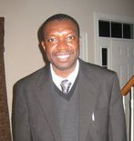

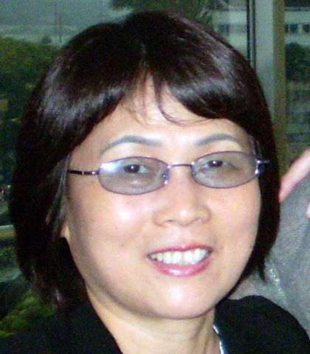

Consumers were asked to provide suggestions on how to promote their wider participation in Cochrane, given the challenge of language.

The Consumers’ Executive will use this information during its next meeting in April of this year. During this meeting the Executive will develop some strategies to better engage this section of our membership.

If you are a consumer who would like to impact these sessions, please send your ideas to Silvana Simi at [s.simi@ifc.cnr.it](mailto:s.simi@ifc.cnr.it)

 I am happy to report that the Consumer Network is taking steps to ensure the inclusion of speakers of non-English languages.  This project is designed to provide a strategic plan on better integration for consumers regardless of language or country of origin.

The effort has been slowly moving forward by gathering volunteers from interested members of CCNet and the wider Collaboration.  E-mails have been sent by Silvana Simi to consumers who are known to speak a language other than English. Consumers were asked for feedback on membership in The Collaboration as a non-English speaker.

**Consumer Vision**

I am Mingming from the Chinese Cochrane Centre. I have been involved in the Collaboration since 1998 and joined CCNet in 1999. My roles in the Collaboration are varied including Cochrane author, consumer, centre co-ordinator and translator.

*Read about Mingming’s vision for a global network of consumers:* [consumers.cochrane.org/blog](http://consumers.cochrane.org/blog)

**Improving Access for Speakers of Non-English Languages**

# *Silvana Simi*

**Informing Consumers, Negotiating Change**

Thanks to a consumer stipend, I had the good fortune to attend my first Colloquium in 2001 in Lyons, France.  There was so much new information to absorb, not the least of which was how the Collaboration worked and how to understand Cochranespeak.

I happened into a workshop in time to hear something shocking and entirely new to me.  The speaker was reporting his review of drug trials and how common it is for the serious adverse events (SAE) data to be withheld.

Why hadn’t I heard this before?

*Read more about Maryann at* [consumers.cochrane.org/blog](http://consumers.cochrane.org/blog)



Try the Cochrane Library for consumers:

<http://summaries.cochrane.org>

## **Standards for Plain Language Summaries**

# *Catherine McIlwain*

The PLEACS initiative is working to develop minimum standards for the content of Plain Language Summaries (PLS). The work is intended to improve the level of detail available to consumers in the summaries.

The PLEACS team consists of three consumers, three consumer co-ordinators, two consumers and communications researchers, two Cochrane editors and three members of Cochrane Review Groups (CRGs). By working together, we hope to devise a set of standards that not only meets the needs of consumers, but also provides an attainable target for those that will implement these standards.

An initial set of standards have been developed and reviewed by a small advisory group of consumers and stakeholders to identify issues in implementation of the standards. These draft standards were presented for discussion during a workshop at the UK and Ireland Contributors’ Meeting, in Loughborough, last month. During that workshop, participants debated an issue that had plagued the PLEACS team, namely, the representation of statistical data in plain language. These comments and others will be taken back to the PLEACS team for consideration later next month.

These standards will be sent to the wider CCNet and Collaboration membership for consideration prior to finalising any recommendations.   
Keep an eye out for this notification, likely to come at the beginning of May. We’d like to ensure that all consumers are represented in this very important piece of work.

*For full information about the background of the project and the formation of the team leading   
this effort, visit*

<http://consumers.cochrane.org/PLEACS>



***Sara Yaron*** *is a private lawyer from Israel, engaged in medical malpractice lawsuits. After her diagnosis, she became involved in patient safety and thei right to updated medical information based on evidence.*

**Campaigning for Evidence**I met The Cochrane Collaboration the first time, at an international conference regarding breast cancer,   
in the late 90’s in Europe. There, I read a brochure, published by CCNet, and fell in love with the idea.

At that time, I was a very young woman diagnosed with breast cancer (grade 3) and a mother of three little children, with one very ill daughter, so I was “thirsty” for any certified, objective written medical information regarding my family’s illnesses…

*Read more about Sara’s story at* [consumers.cochrane.org/blog](http://consumers.cochrane.org/blog)

## **UKCC & Ireland Cochrane Contributors’ Meeting**

# *Gill Gyte*

The conference was fully subscribed with over 200 attendees attending the meeting in Loughborough, England from 20-21 March 2012.  Ten consumers attended the Consumer Network Meeting (see page 6 for details).

**Opening plenary sessions**

Tom Walley, from the National Institute of Health Research (NIHR) (which funds the Cochrane groups in the UK), spoke first on ‘The importance of Cochrane work – a UK success story for the world’.  He praised the work the Collaboration does but explained that funding was not a right and that Cochrane would need to continue to demonstrate its work was relevant to NHS priorities.  At the same time he acknowledged the need for Cochrane to address worldwide issues.  He encouraged Cochrane to prioritise topics, and to engage more with those who want to use Cochrane reviews, such as policy makers, NICE, patients etc.

Martin Burton, new Director of the UKCC, spoke next on ‘Cochrane UK – going forward’.  He explained his background as an ENT clinician and that he still worked in this clinical area.  He, too, was keen to promote the use of Cochrane reviews in clinical practice and his focus for the UKCC moving forward would be ‘engagement’.

**Closing plenary sessions**

David Tovey, Editor in Chief, began the closing session outlining where *The Cochrane Library* was going in terms of access and derivative products.

Phil Alderson, from NICE, spoke of the work that the Collaboration and NICE can do together to get best evidence into practice. He mentioned some of the successes, but also acknowledged some of the difficulties of two large organisations working together both at the level of individual review groups and individual guideline development groups.

Rachel Stancliffe (Centre for Sustainable Healthcare) gave a very interesting presentation of green issues relating to medical research and covered the responsibilities we all share to minimise our carbon footprint in all we do in the Collaboration.

The final speaker was Chris Mavergames, Cochrane Web Manager, who gave us a glimpse to the future of how web technology can help us improve access to the best evidence in the Collaboration and reach a wider audience.

**Overall**

The networking with consumers was invaluable. The help they can give us in providing the support that consumers need to contribute effectively is really important.

*Find out about meetings   
where you live*

<http://www.cochrane.org/news>

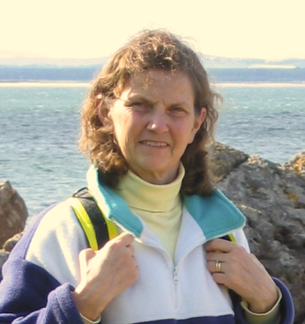

**Consumer   
Editor**

I joined The Cochrane Collaboration in 1997, when the Pregnancy and Childbirth Group (PCG) invited me to help them involve consumers in their work. At the time, I was an antenatal teacher with the UK National Childbirth Trust (NCT) and I was on the NCT Research and Information Group because I had a scientific background. I was interested in PCG because Iain Chalmers had made a distinct impression on me when he spoke at an NCT conference a few years earlier. He presented a systematic review on a new suture material showing more painful intercourse three months after birth, yet this material was still being used. I was incensed and we began a campaign in the NCT to try to change this…

*Read more about Gill at* [consumers.cochrane.org/blog](http://consumers.cochrane.org/blog)

**Cochrane for Dummies: a laywoman-turned-Cochrane enthusiast**

The South Asian Cochrane Network and Centre, which I joined two weeks back, kicked off its training   
workshops for the year 2012 with one on ‘Understanding and Using Systematic Reviews and   
Meta-Analyses in Informing Health Decisions’.   
  
That’s quite a few unpalatable words for a laywoman and under previous circumstances this would have been one workshop that I would have avoided, especially if I had known it had anything to do with medicine. I’m married to a doc and I live in a medical community. So I get more than my fair share of ‘medicated talk.’…   
*Read more at* [*consumers.cochrane.org/blog*](http://consumers.cochrane.org/blog)

***Anna Joseph*** *is the recently-appointed Communications Officer of the South Asian Cochrane Network and Centre, based in India. Anna, who holds a post-graduate degree in Mass Communication, has editorial experience in print and electronic media. As a face of The Cochrane Collaboration, she is trying to be more a Communicator than the Consumer she is by default, essentially more of a Plain Language Summary Person than an Abstract Person, and if she had to go through an Abstract, more likely to look at the Risk Ratios than the Odds Ratios.*

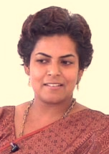

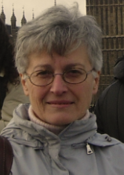

**Family   
Carer &   
Linguist**

I have been   
involved in The   
Cochrane Collaboration (CC) since 1999, when my eldest daughter was diagnosed with multiple sclerosis (MS). I joined the MS Group, and from the beginning I have taken an active role, both as Editor and consumer representative.

Anyway, I have felt myself essentially a consumer, so, since then, I also joined the Cochrane Consumer Network (CCNet), working as a member of its Governing Committee since the network revamping in 2002, and currently as a member of the CCNet Executive…

*Read more about Silvana at* <http://consumers.cochrane.org/blog>

## **UKCC & Ireland Cochrane Contributors’ Meeting**

## **Consumer meetings and workshops**

# *Gill Gyte*

**Cochrane Consumer Network local meeting**

It was encouraging to meet consumers new to the Collaboration as well as touch base with those who have participated over many years. We discussed their needs in terms of support from CCNet. The main areas were: getting feedback on their comments; getting consumers commenting at the title registration stage; training and a buddy/mentoring system.

**Standards for Plain Language Summaries (PLS)**

Catherine McIlwain went through the draft standards that are being developed for Plain Language Summaries and then opened the ideas for discussion.  There was a strong feeling that these standards would create long, possibly complex PLS, where people had imagined PLS would be short, simple and a signpost to more detail if the reader wished to know more (via the abstract or full review). These discussions will continue at the half-year meeting in Paris in April.

**Developing a glossary for PLSs**

Gill Gyte led this workshop and using 12 PLS she had selected at random, she asked participants, in small groups, to identify complex words they would want replaced or not used.  This produced a huge long list of words, and Gill and others will take this work forward to try to produce a Glossary of alternative words which can be used in PLSs to help authors.

**Commenting on a generic checklist for consumer referees**

Gill Gyte, with the help of a small group of consumers, has been trying to develop a generic checklist for consumers commenting on protocols (and reviews) which can be used by all groups.  Gill brought two draft versions for discussion and the main suggestion from those attending was that it would be preferable to have a guideline document explaining the various sections of a Cochrane protocol/review, so that the checklist itself could be short and to the point.  The next version will be discussed at the half-year meeting and piloted shortly afterwards.